Starting The Core Machine Learning Core – Date 21 July 2026

Lets Started

Difference Between AI – ML and DL
- AI – Artificial Intelligence – Like Writing the Rules – Ai Mostly follow the rules or use Learning algorithm

- ML – Machine Learning – Here It will learn From The data
- DL – Deep Learning – humae Feature ko extract karna ki zarorat ni hoti
Deep Learning Auto extract Karta ha – Ya naural Network par kam karta ha

Machine Learning aik Specific data tk e learn kar sakta but deep data ma jitna data ata ha utna improve karta ha that’s the main concept

Deep learnig ko Hum mostly large data Ka Lya use karta hae Or small Data Ka lya
Hum ML ko prefer karta hae

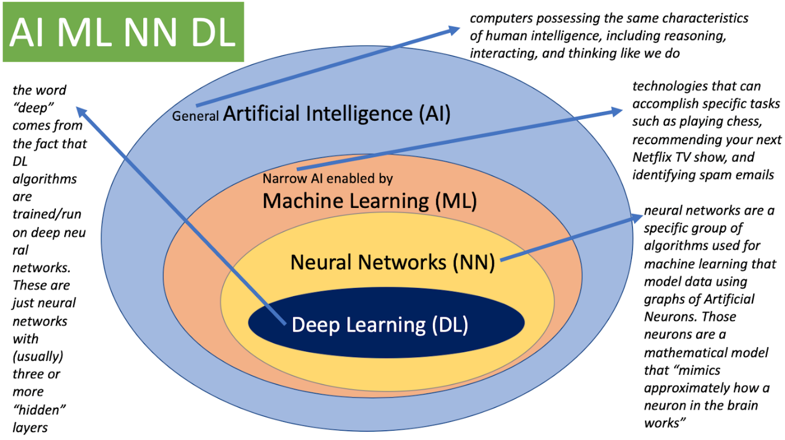

Why doesn't Deep Learning need Feature Engineering?
Answer (improved)
Deep Learning does not require manual feature engineering because it automatically learns the important features from the raw data using multiple neural network layers. Instead of a human defining features, the model discovers them during training

Why does Deep Learning need more data?
"Machine extract the features so for all scenarios it will get all the information that takes a lot of data."
That's the correct idea. Here's the polished version:
Deep Learning models have millions (sometimes billions) of parameters to learn. Since they automatically discover features instead of receiving handcrafted ones, they require much larger datasets to learn accurate patterns and avoid overfitting.

Types Of Machine Learning

Supervised Learning – aisa dataset jis ma input bi ha and output bi ha wo supervised and hum un input output se new result nikalta hae ya supervised hota
Two Points in the Supervisesd :
- Regression : Agar input ka bad output hamara numerical ho like number jaise house prediction is one of the example of This
- Classification : Out agar hamara categorical ho To wo Classification ha Like email spam ha ya nae

UnSupervised Learnig – Unsupervised ma hamara pas just Input hota ha is ma output ni hota ha
- Clustering : Like Grouping karta ha ya Clustering
- Dimentinality Reduction :It will remove the extra columns That are not useful – Like we can take is as the combining the some columns : Dimensionality Reduction reduces the number of features while preserving as much important information as possible

- Anomly Detection : Detect the Outliers here
- Association rule base : Like Rules banana Like a very useful case study in America where an employee suggest to that add milk and diaper in one section so that people can find easily also – My own opinion its very useful like we can make offers like buy 2 Milk pack and get 50 % on beer and other is very useful here so that it’s a very useful Algorithm

SemiSupervised : ya kuch Supervised ha and kuch Unsupervised : Semi-Supervised Learning is a machine learning approach that trains a model using a small amount of labeled data together with a large amount of unlabeled data.

Reinforcement : hum system ko data deta hae r ni wo aista aista ghaltiyan kr ka seekh ka improvement karta ha hud ma That’s what the Reinforcement is

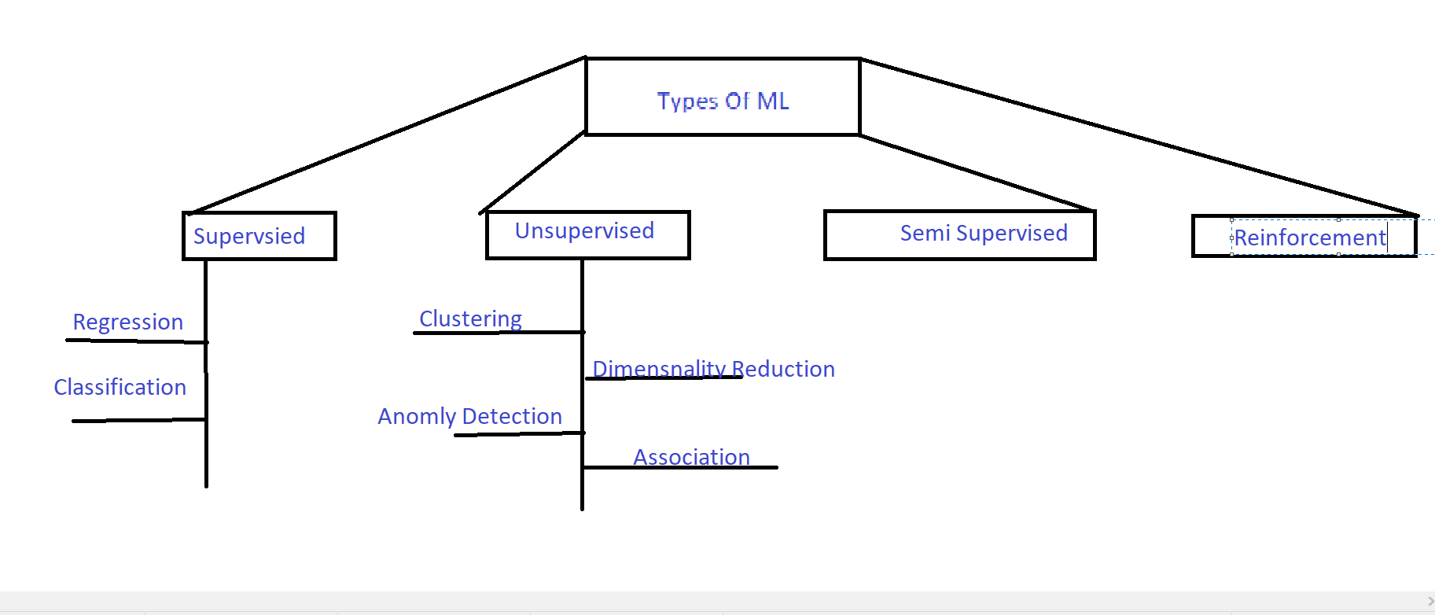

21 July 2026 Ended _ lecture Number 1-3 Completed

New Day – 22 July 2026
Lecture Number 4-5-6 : Expected To end today

- Topic : Batch VS Online ML

Batch Also Consider as The Offline and the Online like deploy on the server

- Batch learning : Like is ma Pura Data se training karta hae like chota chota tukra ma kam nae karta
- Batch learning Mostly hum apna system ma train karta hae and us ko train karna ka bad user us ko deploy kar deta ha Server

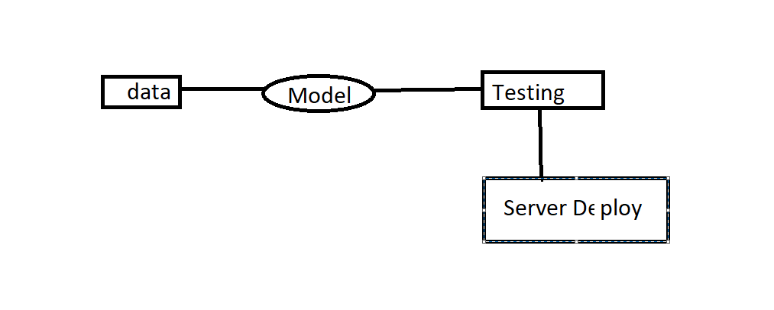

- Is ma issue ya ha ka wo aik bar agar seekh lya ha to wo duabra nae seekh raha us na jo seekha ha wohi rahae ga what about the new data so is sa hamara pattern old e rahae ga – Like email spam kiya then aik saal tk us ko update nae kya then kya ho ga log new technique bn alae ga jis se spma ma nae jae that’s the main c issue in the batch processing concept

Ab Is ka Solution kya ha

- Updated data aya Machine pe dala testing Ki then again deploy on the server

- This is work that was working on the loop again and again

- Issue ya bi smjhana ha ka agar ya loop 24 hr ka bad a raha ha and humae aik news chahiya thi like crypto news so is sa jo data likeCpi data humae foran chahiya hota ab wo data humae aik din bad aae to us ka maqsad hartam ho gya so these are the cases where we can not considering the batch processing

- Online Machine Learning : is ma hum sever ma data ko automatically Train karta rehta hae like chatbot is the main example and youtube is also an online learnig like jo data user enter kara ga us se learn kar ka ab wo seekha ga automaticallay

- Main Question Is When to use the Online and Where To use The Batch Learning

- 1 jahan humae continuous learnin gchahiya ho gi wohan hum online karaega

- Disadvantages
- Tricky to use
- Risky
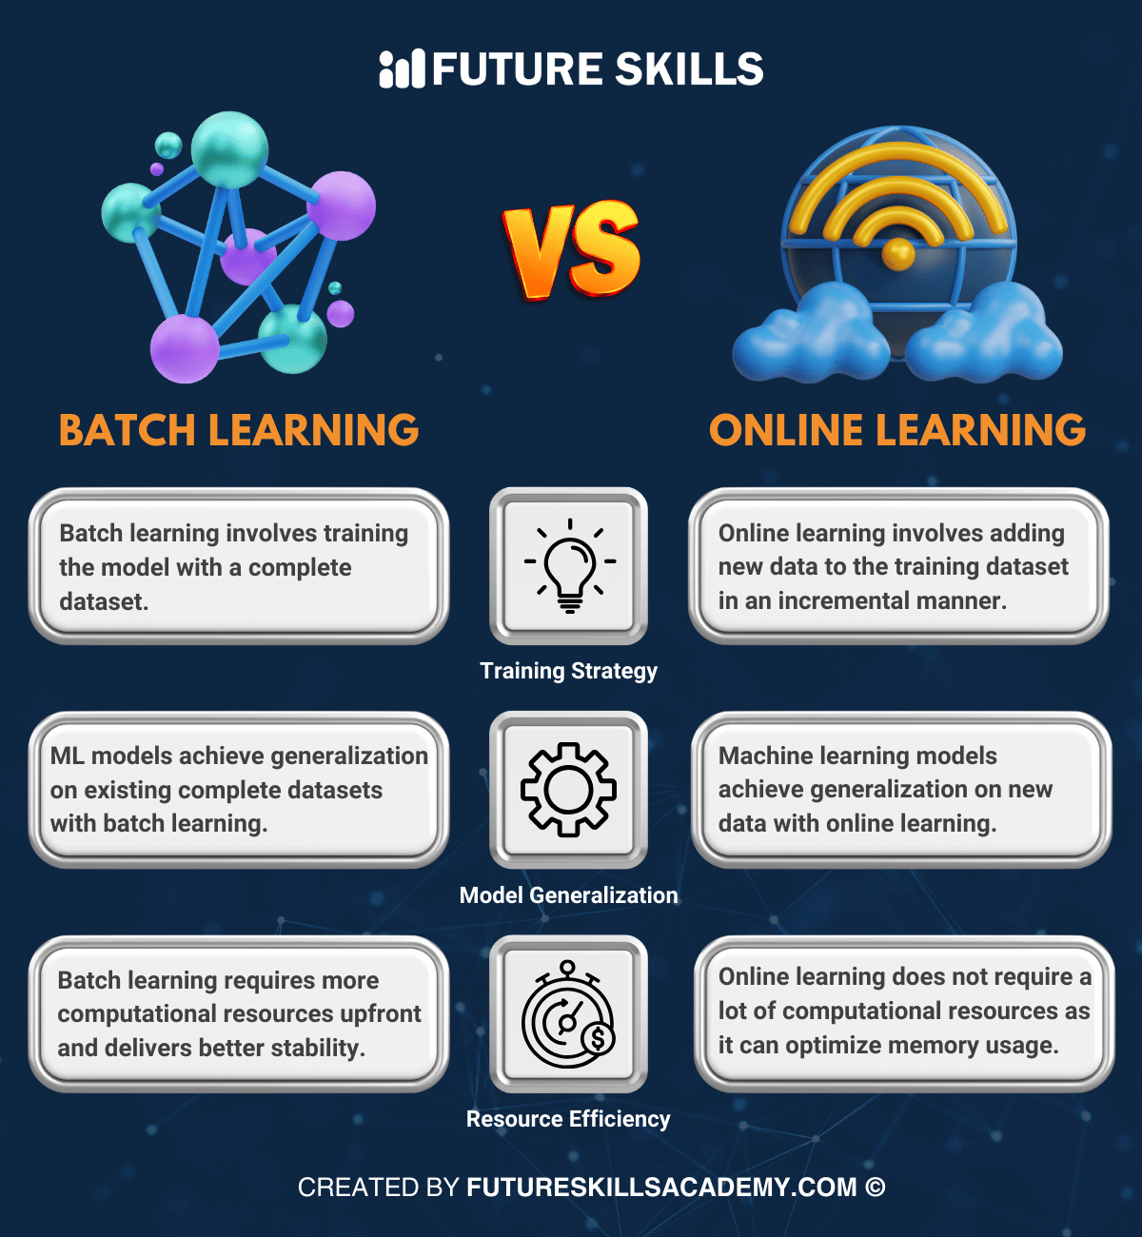

- Instance Vs Model Base Learning

- Instance Based : Instance base ya karta ha ka us ka pas jo data hota ha us ko use karta halike new data jab ata ha wo previous se compare karta ha and us ka nearnest wla jo bi answer hota ha wo de data ha
- Instance-Based Learning stores the training data. When a new input comes, it compares it with similar previous examples and predicts the output.
- Training Data

- House 1000 sqft → 100K

- House 1200 sqft → 120K

- House 1500 sqft → 150K

- New House

- 1300 sqft

- ↓

- Find nearest houses

- ↓

- Predict

- Model Based
- Model base aisa karta ha ka us ko jo data milta ha us se learn karta ha pattern bnata ha jab us ka pas new data ata ha to wo us ko predict karta ha like jo us se learn kya hota ha pattern us sa data ko predict karta ha that is the main concept in the Model based Learnig
- Old Data

- ↓

- Learn

- ↓

- Create Brain

- ↓

- Answer

Instance-Based
Looks at old examples before answering.
Model-Based
Learns the pattern once, then answers without looking at the old data again.

- Problems in The Machine learning
- Data Collection- Difficult ha data lena l
- Insufficient data –
A ka pas 100 ka data ha rows
B ka pas 1000000 rows data ha
Hum B ko Choose karae ga because besahka a beeter ans de hum Zaida data wla ka
Pas jae ga because for more trust
- Non representative data – Ml Problem solve karna jar aha or ap ka data incomplete ha so is se result bi ghalat ae ga- like acha se data collection ya selection nae hoe data representations e both issue hota
- Poor Quality data – include missing data , oulers ,and other problem agar data ki quality ghalat hoe to issue hota ha and 60 % AI/Ml ma data cleaning ka kam ha
- Irrelevant feature – irrelevenat future dalna se issuer ho sakta like garbage feature sap hir output bi garbage output e mila ga in simple word ma hum ya bol sakta hae
- OverFitting – Overfitting aik model ko aik data pr train kya magae us na sir raat ha magar learn ni kya data se so new input se wo acha output ni de ga again- like ma new city ma gya or aik shop se koe chez le li wo harab thi ma na ab sich lya is city ma har cheez harab ha .
Overfitting occurs when the model learns the training data too closely, including noise and unnecessary details. As a result, it performs well on training data but poorly on new unseen data.

- Underfitting – is ma Matlab kuch Zaida socha e ni just us na simple output de di
Underfitting occurs when the model is too simple to learn the patterns in the data, resulting in poor performance on both training and testing data.
- Software Integration – hum model ko ksi software ma integrate karta hae and its very difficult ha
- Offline learning and Deployment – Same batch learning
- Cost Involved – tuu Much Cost
- Generalization
- This connects Overfitting and Underfitting.
- Definition:
- Generalization is the ability of a machine learning model to perform well on new unseen data.
- The goal of every ML model is good generalization.

- MLOPS use hota ha machine learning ki deployment ma

End Of July 22 – completed till lecture number 7

New Day Started - Date Is 23 june 2026 – Lecture 8-9-10 Expected to done Add-11

Lets Started

- Applications Of The Machine Learning

- Machine learning Development Life Cycle

Simple Like Its Roadmap

SDLC Proceess : How To Built Software From Start To The End

For This Its

- M L D L C - ( Machine Learning Development Life Cycle )

- Framing The Problem – Like Apna Problem Ko Correctly frame kr lana chahiya ka kaise kon sa Kam Kaise karna hae
- Geathering The Data – Getting The data and Convert In to the Specific Format
- Data Preprocessing – Data lana Ka bad Us ma Sa us ko Useful Data ma Lana hota ha like missing Values ko remove karta hae , nullable remove and other
- Exploratory Data Analysis – Idr Hum analyze karta hae realtion karta hae graph wagaira ya sab hum idr karta ha e
- Feature Enginerring and Selection – Like Hum new columns create karta hae ya hum kuch specific colums bna leta koe or columns ko mix kar ka
- Model Training Evalation And Selection – Here we Can Select The Useful data like Hum different algorithm use karta and un ma se check karta hae ka kon sa model humae useful information De raha ha – Also hum kuch model ko mix kar ka aik new powerful model bna leta hae
- Model Deployment – ab jo model Bana Hota ha us ko hum aik software ma change karta hae – Hum like model ko aik api ma convert kar lata hae and then like hum python se and then wo humae json ya jis Trha Ki File Ap chahta ho le sakta
- Testing – Deployement ka bad hum deakhta hae ka model kaise behave kar raha ha
- Optimize – Server Pr Launch kar leta hae – and Hum model ka backup , data ka backup loadbalancing and different useful cheezain use karta hae

- Data Analyst – Data ana ka bad us ko analysis krna hota ha like cleaning and realtion and Eda -Sql , Advanced Excel Python
- Data Enginerring – ya first banda ha ya data ka ke data ha data base se data warehouse banana ha –
- Languages ani chahiya python wagaira – tools ana chahiya like apache ,hadop
- Data pipelines bananni ani chahiya
- Data Scientist – ya sab kuch hota ha like wo flow jo ha wo in ka sab kam kar sakta hou like past and the feature sab ka bara ma Pta hona chahiya – It’s a Full Stack – Main row in create model simple – Math important software important ,aanalytical skills Matter
- ML enginner – ya model banna ka bad us ko integrate karwata ha is ka kam sab se kam hota ha – Skills , programming ani chahiya , Software cycle ana chahiya

- TENSOR

- Tensor Is nothing just a Data Structure Like Data Ko Store karna ka tarika
- Mostly Number ko Store karna ka Lya aik Box In Simple Word
- Matrix And Vector Is Actually a Tensor

- Axis Mean How many Dimention and number of axis ko rank bolta hae
0D Tensor – Like simple number store karna ga
1D tensor – [1 2 3 4]
2D Tensor – [[1,2,3],[4,5,6],[7,8,9]]
ND Tesnor

ML ma Mostly Hum 1-5 D tak e use karta hae
Rank – no of dimention or np of axis
Shape like kitna rows and kitna columns hae

2D Tensor It’s a Collection Of The 1D tensor
3D Tensor – textual data ma 3 D Hota ha mostly
Hi Talha
Hi Naeem
Hi Bilal
Acha ab hae word ko inique bna lo
Hi | Talha | Bilal | Naeem
1 | 0 | 0 | 0
0 | 1 | 0 | 0
0 | 0 | 1 | 0
0 | 0 | 0 | 1

Ab deakho Hi Talha
[[1,0,0,0],[0,1,0,0]] ya bna ga

Aba 3D kaise bna ga
[
[[1,0,0,0],[0,1,0,0]], [[1,0,0,0],[0,0,0,1]], [[1,0,0,0],[0,0,1,0]] ]

Today 22 July Ended Lecture Completed Till 11
26 July – Completed end to end Project of Logistic regression

- Lecture Number 14 In Machine Learning
- How to frame a Machine Learning Problem
- Bussiness Problem Is The Increase The Revenue
- Best Approach is ksi bi problem ko math matical ma convert karna ha First Step

- Example Related – Netflix
- Like Revenue Kaisa barhaya jae
- Different approaches like increase money of pkg - better market
- But The Main is The Reduce the chunk Rate
- Chunk Rate – ya aise samjo ka like har mahina company ka 2% log ka mho raha hae like jan ma 2% 100 ma sa ab feb ma 98% tha and 2% reduce like isi trha
- Question Here – aisa to company doob jae gi no Answer is that new user hamesha ata rehta hae and un ka montly rate chunk rate se Zaida e hota ha
- Ab target ya ha ka agar 4% ha to 3.75% l pr laya jae
- Ab ata ha 2nd step ab hum Big Picture par kam karae – like if you want to reduce the chunk rate we have to find ka kon sa log abi jana wla hae
- Ab hum nay a karna ha ka hum un ki kaiser ok sakta – like discount , solve that user problems
- Ab ya bat ha ka har ksi ko kaisa manage karae like hum jhar ksi ko aik jaisa to ni de sakta hum ab ya karae ga ka kon sa banda chorna ki probability Zaida ha us ko Zaida discount and jis ki probability kam ha us ko kam discount is se better approach ha

- Now The next Is The where we get the data – Like Watch Time – Browsing Etc is trha like us na kitna movies search kya or kitna data us ko mila or us ko kitna data nae mila ha is ka ilwa ya ka lkitna banda mid ma e chor rahae hae movies ya kuch isi tarha jo bi ho hum is ko isi Tarha manage karae ga

- Now Next Concept is The Working With the Csv – lecture number 15
- Aj hum geathering data pr kam karae ga sab karika samjae ga ka kon kon se tarika se useful data geather ho ga

- CSV , Done on lecture 15

- Json/SQl , on lecture 16

- fetch from api ,17

- web scraping : What is Web Scraping?
- You can answer:
- Web Scraping is the process of automatically collecting data from websites. First, we send a request to the website, receive its HTML source code, parse it using BeautifulSoup, extract the required information, and finally store it in a structured format such as a Pandas DataFrame or CSV file.

- DoNE Till now

- LECTURE 19 – Understanding of the data

- Asking The Basic Questions
- EDA ( Uni_Varient Analysis )- Matlab single variable ka analysis ko univariant kehta – This was done In The lecture 20
- EDA (bi Varient Analysis ) – Jab 2 variable ka analysis karae hum _ Done in lec 21
- EDA ( Multi_varient Analysis ) – jab 2 sa Zaida par analysis karae us ko Multi bolta – done lecture 21
- Pandas Profiler ( all Done By The One Library ) – Done on lecture 22

- Now Started The Feature Engineering – Lecture Number 23 and On-Wards
- Like hamara pas jo data ha us ko direct use nae kar sakta like hum apna model ko direct nae de sakta hae hum us data ko prepare karna hota ha that’s why
- Like is ko aisa samaj lo ka agar aik ghatya algo ko aik acha feature do to wo acha model jis ka bura data diya gya ha us se better perform kara ga
- 1 : Feature transformation – is ma Missing value handing categorical outlier detect and feature scaling
- 2: feature construction – is ma hum aik new colums create karta hae like aikk col ma child likhae kae 4 hae aik colum ma un ka sth family hum aik new bna leta hae ka column bnao jis ma aik add kar lo
- 3 : feature selection – is ma like hamara sath both Zaida input ma sa Kuch selected wali rows ko select karta hae
- 4: feature Extraction : is ma hum apna colums ma sa bilkul new data create karta hae r

- Feature Scaling – Like apna data ko aik fixed range ma le kar ana
- Why we need the feature scaling – issue ya hota ha ka jab 2 values ma both difference ho like 12 , 100000 and 34,134343434 ab in ka difference nikalae ga to 32 and 12 ka difference kam ha but dusra number ka difference both bara ha so model itna acha perform nae kara ga
- Its has two techniques –
- Standarization – It was also known as the Z-score is ka formulae ho gya
xi-xbar/standarddaviation

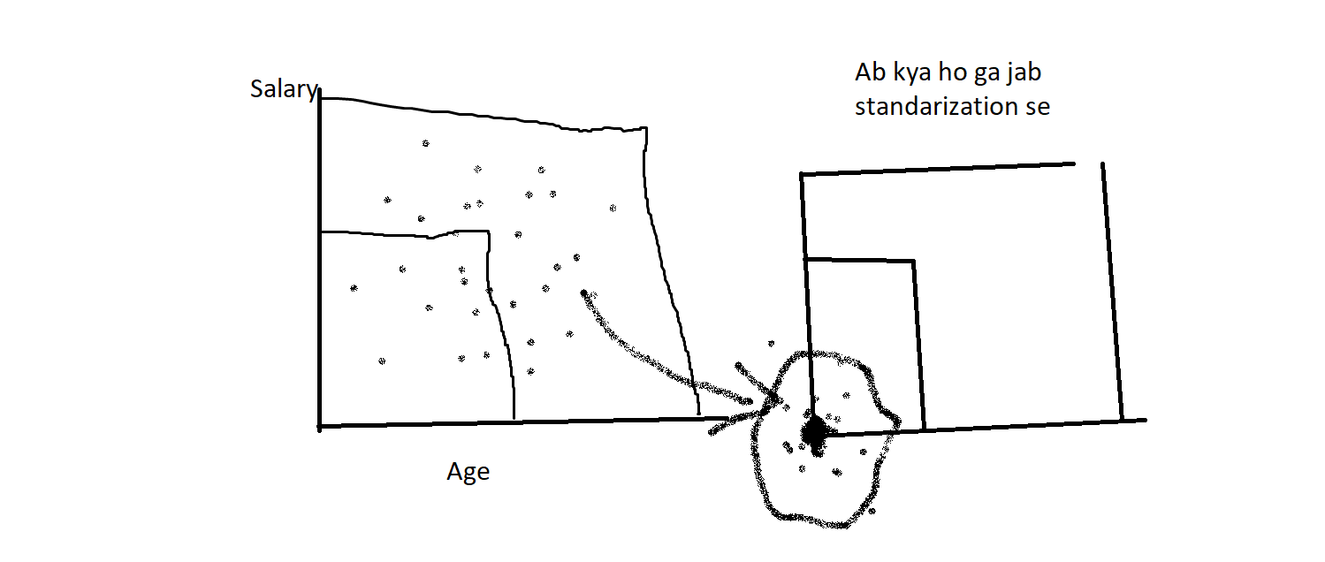

Standarization Kab lagana chahiya :
- Kmeans ,kNN ,PCA,ANN,Gradient descent pr in sab par scalarStandard() har hal ma lagta ha

29 July – Ended lectures Till 24 Now I will Practice

- Feature Scaling – Normalization
- Normalization and their Types
1 : Min – Max Normalization
2 : Mean Normalization
3 : Max Observation
4 : Robust Scaling

- Mix – Max Scaling :
Weight : 67 , 81 , 130, 61 , 32 , 54

Formulae = Xi – Xmin / Xmax – Xmin

Is ma Hamesha 0 – 1 Ki range ma Ata ha Data

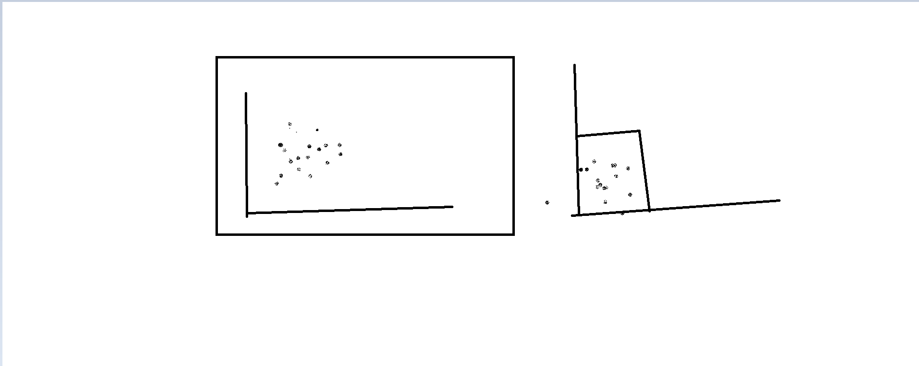

Question :
Can I use Normalization instead of Standardization?
Answer:
Yes, sometimes both can work. However, Standardization is generally preferred for algorithms like Linear Regression and Logistic Regression, while Normalization is preferred for distance-based algorithms like KNN and K-Means.
- Mean Normalization – Formulae = xi-Xmean/Xmax-Xmin
- MaxAbsScaling – Xi/| Xmax| jis data ma 0 boht hae us ma ya use hota ha
- Robust Scaling – Xi-Xmedian/IQR{75PercentValue-25percentValue} If data ma Zaida outliers hae to ya may Be Acha Perform kar de

- Normalization Vs Standarization –
- Is feature Scaling Required ?
- After Sure – Normalization Or Standarization
- Answer many Algo Perform Well on Standarization
- So Normalization humae us Waqt use hota jab huame pta ho ka humae min and max ka pata hona chahiya

Lecture 25 Done
- How To Encode The Categorical Data

- Encoding The Categorical Data
- What actually is this
- Actually there is two type of the data
- 1: numerical and 2 : categorical
- In Categorical there is two types
- 1 : nominal and 2: ordinal
- Nominal : Jis ma Categories ma koe relation na ho – Like karachi Islamabad
- Ordianl : jis ma Categories ka beach ma realtion ho -like grades , positions etc

- Two Ways to Do This
1 Ordinal Encoding
2 One Hot Encoding
3 label encoding

1. Binary Encoding (0/1)
Use when: The feature has only 2 categories.
Examples:
- Male / Female
- Spam / Not Spam
- Yes / No
Example:
Male → 1
Female → 0

2. Ordinal Encoding
Use when: The feature has more than 2 categories and there is a natural order (ranking).
Examples:
- Small → Medium → Large
- Poor → Average → Good → Excellent
- High School → Bachelor → Master → PhD
Example:
Small → 0
Medium → 1
Large → 2
Reason: The order is meaningful.

3. One-Hot Encoding
Use when: The feature has more than 2 categories and no natural order.
Examples:
- Cities (Lahore, Islamabad, Karachi)
- Fruits (Apple, Banana, Mango)
- Departments (HR, IT, Finance)
Instead of assigning numbers, create separate columns.
Example:
Fruit | Apple | Banana | Mango
Apple | 1 | 0 | 0
Banana | 0 | 1 | 0
Mango | 0 | 0 | 1
Reason: The model should not think one category is greater than another.

Quick Decision Rule
Only 2 Categories
↓
Use Binary Encoding (0/1)

--------------------------------

More than 2 Categories
↓
Is there a natural order?

↓ YES
Use Ordinal Encoding

↓ NO
Use One-Hot Encoding

Easy Memory Trick
- 2 Categories → Binary Encoding (0/1)
- Ranking Exists → Ordinal Encoding
- No Ranking → One-Hot Encoding
One main Point agar input ma male , female a jae then bi hum hot encoding karae ga use – simple encoding like male ko 0 and female 1 ya agar output hota to hum karta I hope getted the ideas

- One hot encoding – Like Colors yellow green blue
- Ab is ka chakar ya ha ka sab columns bna ka end ma aik column to hatana hota ha that’s the dummy variable trap –
- MIlticollinarity – like hamra input ma koe relation ni hona chahiya
- So qn agar blue red and yellow ha and hum na blue hata dya to humae kaise pta laga ga blue ka
- Is ka ans like yellow 1 red 0 so blue is 0 also yellown 0 red 0 blue is 1
- So aik Or Question ha ka agar aik ma 40 a jati hae categories so kya hona – us ka lya simple hum jo frequent hae un ka colm bnae hga remaining ko other ma dal dena
Today Done Till 27 lecture

- Column Transformer – class in Sklearn

